**Lab6 Pre-Lab Report**

Ziyao Chen

1002453409

**Part1**

2. Synchronous reset, it is active low. We first want to set reset to 0, then start simulation.

3.

|  |  |  |
| --- | --- | --- |
| Current State | Input | Next State |
| A | 0 | A |
| A | 1 | B |
| B | 0 | A |
| B | 1 | C |
| C | 0 | E |
| C | 1 | D |
| D | 0 | E |
| D | 1 | F |
| E | 0 | A |
| E | 1 | G |
| F | 0 | E |
| F | 1 | F |
| G | 0 | A |
| G | 1 | C |

4.

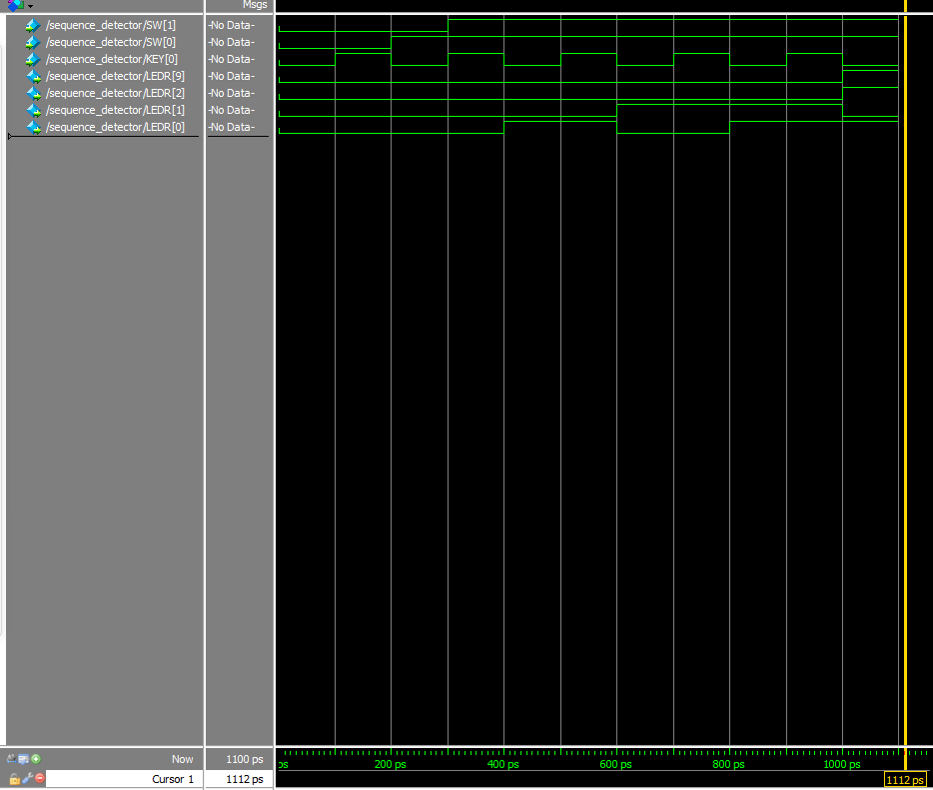

**Part2**

2.

|  |  |  |
| --- | --- | --- |
| Description | Control signals | Register states |
| Load A to register A | data_in = A  ld_alu_out = 0  ld_a = 1  ld_b = 0  ld_c = 0  ld_x = 0  ld_r = 0  alu_select_a = 00  alu_select_b = 00  alu_op = 0 | Register A = A  Register B = 00000000  Register C = 00000000  Register x = 00000000 |
| Load B to register B | data_in = B  ld_alu_out = 0  ld_a = 0  ld_b = 1  ld_c = 0  ld_x = 0  ld_r = 0  alu_select_a = 00  alu_select_b = 00  alu_op = 0 | Register A = A  Register B = B  Register C = 00000000  Register x = 00000000 |
| Load C to register C | data_in = C  ld_alu_out = 0  ld_a = 0  ld_b = 0  ld_c = 1  ld_x = 0  ld_r = 0  alu_select_a = 00  alu_select_b = 00  alu_op = 0 | Register A = A  Register B = B  Register C = C  Register x = 00000000 |
| Load x to register x | data_in = x  ld_alu_out = 0  ld_a = 0  ld_b = 0  ld_c = 0  ld_x = 1  ld_r = 0  alu_select_a = 00  alu_select_b = 00  alu_op = 0 | Register A = A  Register B = B  Register C = C  Register x = x |
| Calculate A * x and load to register A | data_in = N/A  ld_alu_out = 1  ld_a = 0  ld_b = 0  ld_c = 0  ld_x = 0  ld_r = 0  alu_select_a = 00  alu_select_b = 11  alu_op = 1 | Register A = Ax  Register B = B  Register C = C  Register x = x |
| Calculate Ax * x and load to register A | data_in = N/A  ld_alu_out = 1  ld_a = 0  ld_b = 0  ld_c = 0  ld_x = 0  ld_r = 0  alu_select_a = 00  alu_select_b = 11  alu_op = 1 | Register A = Ax2  Register B = B  Register C = C  Register x = x |
| Calculate B * x and load to register B | data_in = N/A  ld_alu_out = 1  ld_a = 0  ld_b = 0  ld_c = 0  ld_x = 0  ld_r = 0  alu_select_a = 01  alu_select_b = 11  alu_op = 1 | Register A = Ax2  Register B = Bx  Register C = C  Register x = x |
| Calculate Ax2 + Bx and load to register A | data_in = N/A  ld_alu_out = 1  ld_a = 0  ld_b = 0  ld_c = 0  ld_x = 0  ld_r = 1  alu_select_a = 00  alu_select_b = 01  alu_op = 0 | Register A = Ax2 + Bx  Register B = Bx  Register C = C  Register x = x |
| Calculate Ax2 + Bx + C and load to register A | data_in = N/A  ld_alu_out = 1  ld_a = 0  ld_b = 0  ld_c = 0  ld_x = 0  ld_r = 1  alu_select_a = 00  alu_select_b = 10  alu_op = 0 | Register A = Ax2 + Bx + C  Register B = Bx  Register C = C  Register x = x |

3.

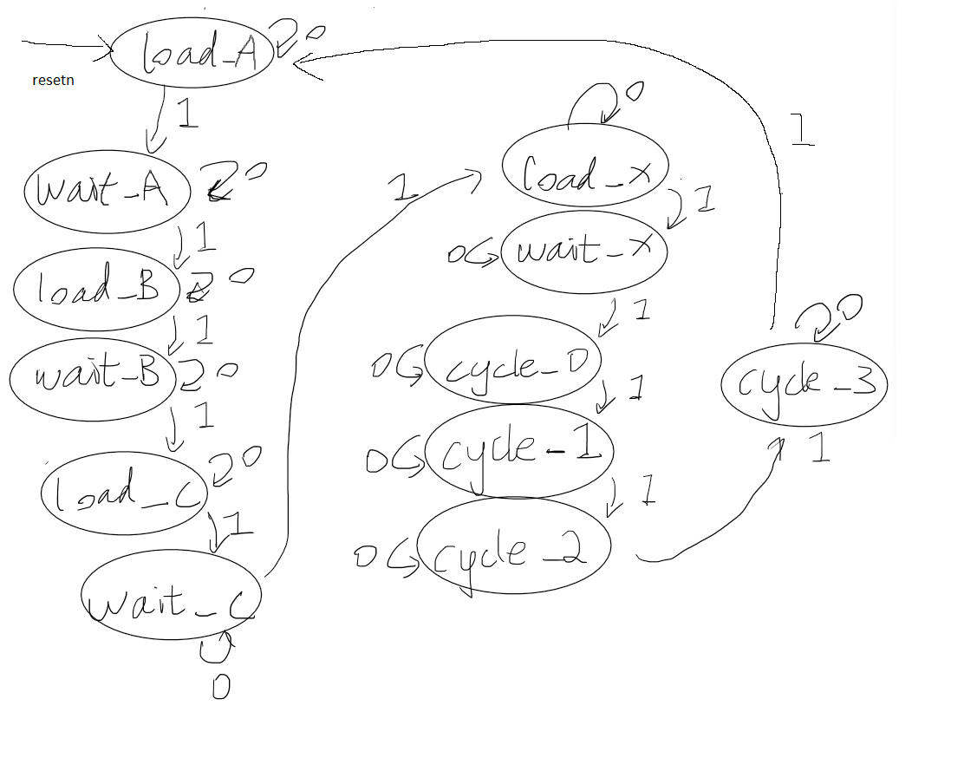

4. module control(

input clk,

input resetn,

input go,

output reg ld_a, ld_b, ld_c, ld_x, ld_r,

output reg ld_alu_out,

output reg [1:0] alu_select_a, alu_select_b,

output reg alu_op

);

reg [3:0] current_state, next_state;

reg status;

localparam S_LOAD_A = 4'd0,

S_LOAD_A_WAIT = 4'd1,

S_LOAD_B = 4'd2,

S_LOAD_B_WAIT = 4'd3,

S_LOAD_C = 4'd4,

S_LOAD_C_WAIT = 4'd5,

S_LOAD_X = 4'd6,

S_LOAD_X_WAIT = 4'd7,

S_CYCLE_0 = 4'd8, // load Ax to register A

S_CYCLE_1 = 4'd9, // load Ax^2 to register A

S_CYCLE_2 = 4'd10, // load Bx to register B

S_CYCLE_3 = 4'd11; // load Ax^2 + Bx to register A

S_CYCLE_4 = 4'd12; // load Ax^2 + Bx + C to register R

// Next state logic aka our state table

always@(*)

begin: state_table

case (current_state)

S_LOAD_A: next_state = go ? S_LOAD_A_WAIT : S_LOAD_A; // Loop in current state until value is input

S_LOAD_A_WAIT: next_state = go ? S_LOAD_A_WAIT: S_LOAD_B;

S_LOAD_B: next_state = go ? S_LOAD_C : S_LOAD_B; // Loop in current state until value is input

S_LOAD_B_WAIT: next_state = go ? S_LOAD_B_WAIT: S_LOAD_C;

S_LOAD_C: next_state = go ? S_LOAD_X : S_LOAD_C; // Loop in current state until value is input

S_LOAD_C_WAIT: next_state = go ? S_LOAD_C_WAIT: S_LOAD_X;

S_LOAD_X: next_state = go ? S_CYCLE_0 : S_LOAD_X; // Loop in current state until value is input

S_LOAD_X_WAIT: next_state = go ? S_LOAD_X_WAIT: S_CYCLE_0;

S_CYCLE_0: next_state = S_CYCLE_1;

S_CYCLE_1: next_state = S_CYCLE_2;

S_CYCLE_2: next_state = S_CYCLE_3;

S_CYCLE_3: next_state = S_CYCLE_4;

default: next_state = S_LOAD_A;

endcase

end // state_table

// Output logic aka all of our datapath control signals

always @(*)

begin: enable_signals

// By default make all our signals 0

ld_alu_out = 1'b0;

ld_a = 1'b0;

ld_b = 1'b0;

ld_c = 1'b0;

ld_x = 1'b0;

ld_r = 1'b0;

alu_select_a = 2'b00;

alu_select_b = 2'b00;

alu_op = 1'b0;

case (current_state)

S_LOAD_A: begin

ld_a = 1'b1;

end

S_LOAD_B: begin

ld_b = 1'b1;

end

S_LOAD_C: begin

ld_c = 1'b1;

end

S_LOAD_X: begin

ld_x = 1'b1;

end

S_CYCLE_0: begin // Do A <- A * x

ld_alu_out = 1'b1; ld_a = 1'b1; // store result back into A

alu_select_a = 2'b00; // Select register A

alu_select_b = 2'b11; // Select register x

alu_op = 1'b1; // Do multiply operation

end

S_CYCLE_1: begin // Do A <- Ax * x

ld_alu_out = 1'b1; ld_a = 1'b1; // store result back into A

alu_select_a = 2'b00; // Select register A

alu_select_b = 2'b11; // Select register x

alu_op = 1'b1; // Do multiply operation

end

S_CYCLE_2: begin // Do B <- B * x

ld_alu_out = 1'b1; ld_b = 1'b1; // store result back into A

alu_select_a = 2'b01; // Select register B

alu_select_b = 2'b11; // Select register x

alu_op = 1'b1; // Do multiply operation

end

S_CYCLE_3: begin // Do A <- Ax^2 + Bx

ld_alu_out = 1'b1; ld_a = 1'b1; // store result back into A

alu_select_a = 2'b00; // Select register A

alu_select_b = 2'b01; // Select register B

alu_op = 1'b0; // Do multiply operation

end

S_CYCLE_4: begin

ld_r = 1'b1; // store result in result register

alu_select_a = 2'b00; // Select register A

alu_select_b = 2'b10; // Select register C

alu_op = 1'b0; // Do Add operation

end

// default: // don't need default since we already made sure all of our outputs were assigned a value at the start of the always block

endcase

end // enable_signals

// current_state registers

always@(posedge clk)

begin: state_FFs

if(!resetn)

current_state <= S_LOAD_A;

else

current_state <= next_state;

end // state_FFS

endmodule

5.

6.

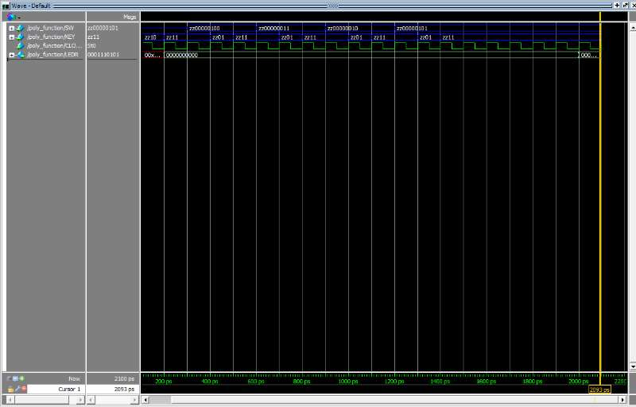

**Part3**



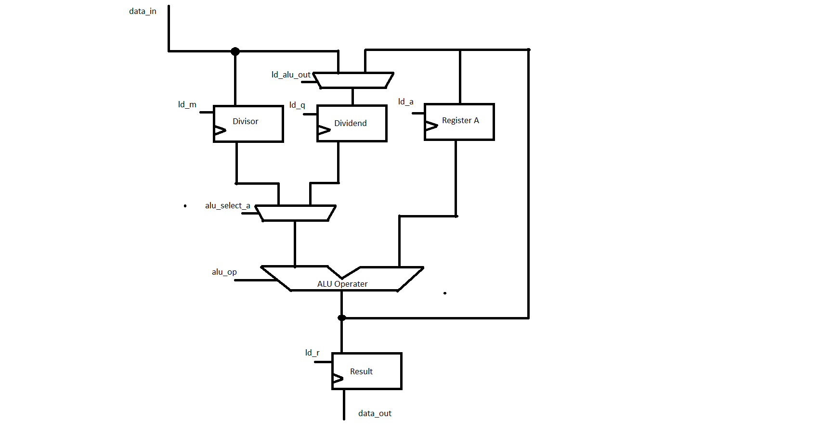



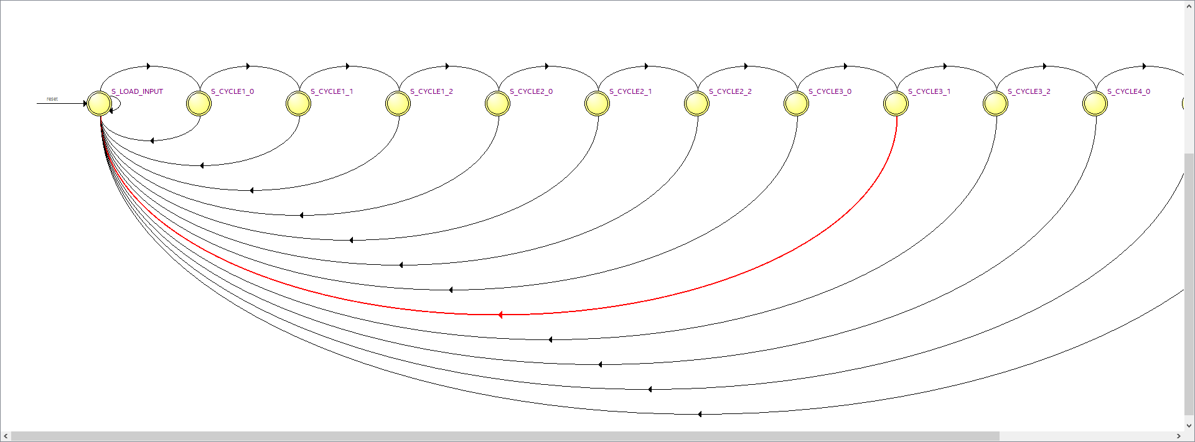



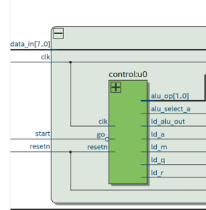



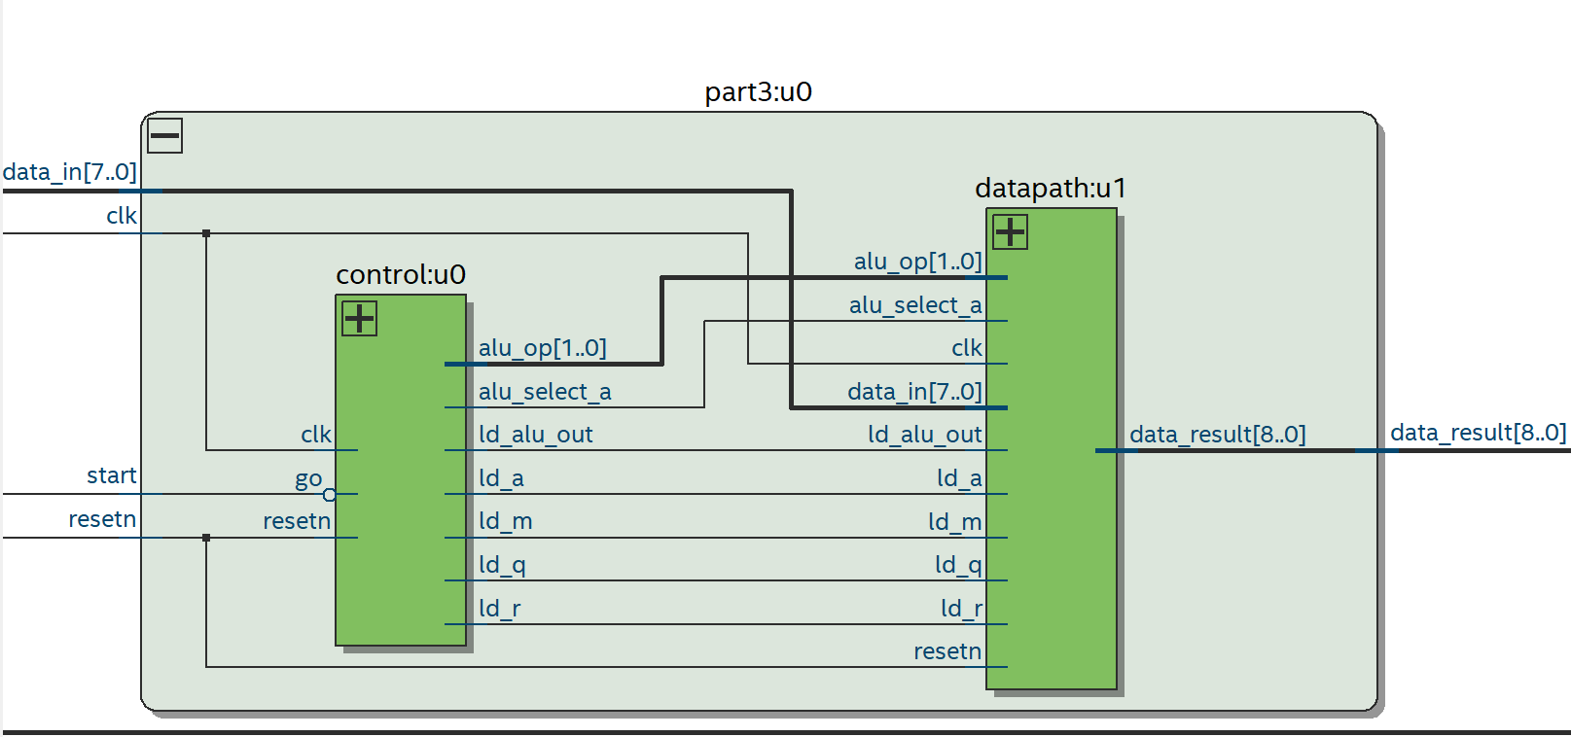



Show TA on computer



